**Adding Custom Decks to Warno:**

I will demo how to create a custom Deck. The example Deck I use is called“ US_ALL“ and contains all Units from the US. This Guide is done for the GOUVION update so things may change.

1. GameData🡪Generated🡪Gameplay🡪Decks🡪Divisions.ndf

First of all, we need to create our Division in the Division.ndf File. Best ist o copy an existing one and just change some things around like you need them. I copied them from the 8th Inf Division in the example case.

Things you need to change:

Name of Division: Like you can see in the top of the added example you need to give the Division a unique Name. I would recommend to Name it Somewhat like: Descriptor_Deck_YOURDIVNAME

DescriptorId: here we need to add a new generated GUID. You can create them yourself here: <https://guidgenerator.com/online-guid-generator.aspx> . Just generate one and copy them in the GUID.

DivisionName: This is the Display Name you can see when selecting a division in game. You can eighter copy it from another Division or leave it blank like in the example. It is currently not possible to create new ones that don’t exist in game.

DivisionNatinality/DivisonTag: They are obvious you can change them if you want.

Packlist: here you can add your Units you want to have within the Division. Copy them from other Divisions. The number is how many cards of this Unit will be possible to be used. Just as example i only have 4 Units in but pack in how much you want, I just wanted the Picture to be too long. Reminder: a division to work needs at least 1 command unit so make sure that one is added here.

MaxActivisionPoints: Here you can set how many points you can spend in cards when using that Division. Honestly let it at the Standard 50 and change the costs later when we come to the DivisionCostMatrix.ndf

CostMatrix: This field links the Division to the DivisionCostMatrix which we will create in the next step. So name it however you want but this needs to be the same like in the DivisionCostMatrix.ndf we configure in the next step.

EmblemTexture/ PortraitTexture/ TypeTexture/ CountryId: These are obvious as well. Just copy from other divs if needed or keep them like they are.

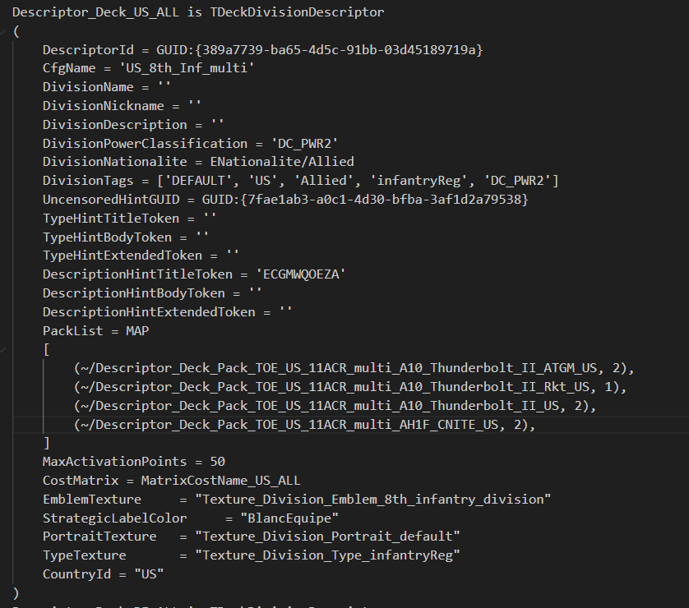

Division Name

GUID

Display Name

All the Units you want in the Division

Link to the DivisionCostMatrix.ndf

1. GameData🡪Generated🡪Gameplay🡪Decks🡪DivisionCostMatrix.ndf

In the Division Cost Matrix, we determine how many slots we have for AIR, Logistics, Inf… etc. and how much they cost. Just copy an existing one and modify it. Make sure to give the Matrix the Name you set in the Divisions.ndf within the CostMatrix before. Each number per line defines a slot in game for the category and the value of the number how much this slot costs in Activision Points so e.g. (EDefaultFactories/Logistic, [1, 3]), means in the Logistic tab you can at maximum fill 2 slots with units and the first slot costs 1 Activision Point and the 2nd 3 Activision Points.

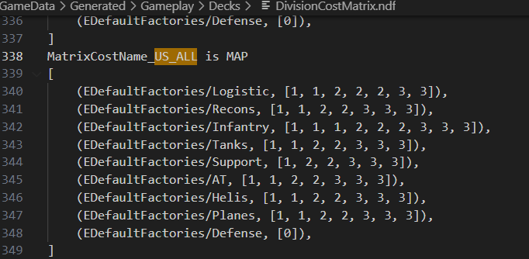

Logistic

Recon

Infantry

Artillery

Helicopter

Planes

Matrix Cost Name need to be same as CostMatrix in Divisions.ndf

Tanks

1. GameData🡪Generated🡪Gameplay🡪Decks🡪DivisionRules.ndf

So now we need to give all Units we added into the Divisions.ndf a Description. Here we Add how many Units per Card and at which Skill Level we can add them. Best is to copy it again from another Deck and modify it. First change the Name to „~/Division Name“like you can see in the example. Then copy for each Unit you have added in the Divisions.ndf the TDeckUniteRule and add it to the UnitRuleList. Best is o just search for the Unit and copy the TDeckUniteRule over. AvaiableWithoutTransport and NumberOfUnitsInPack should be self-explanatory. NumberOfUnitsInpackXPMultiplier basically describes, how many Units you have for which Experience. Basically, you can see it as NumberOfUnitsInPack * NumberOfUnitsInpackXPMultiplier for [Green, Trained, Veteran, Elite]. So, take for example in the Picture the A10_Thunderbolt_II_ATGM_US we could select in the Armory between2 Units for Veteran or 1 Unit Elite. Since the Multiplier for Green and Trained is 0.0 we could not select them.

IMPORTANT: If you in game see that a Unit in your Custom Deck has all 4 Experience Levels unlocked this might be an indicator, that you forgot to add the Unit into the DivisionRules for your Deck.

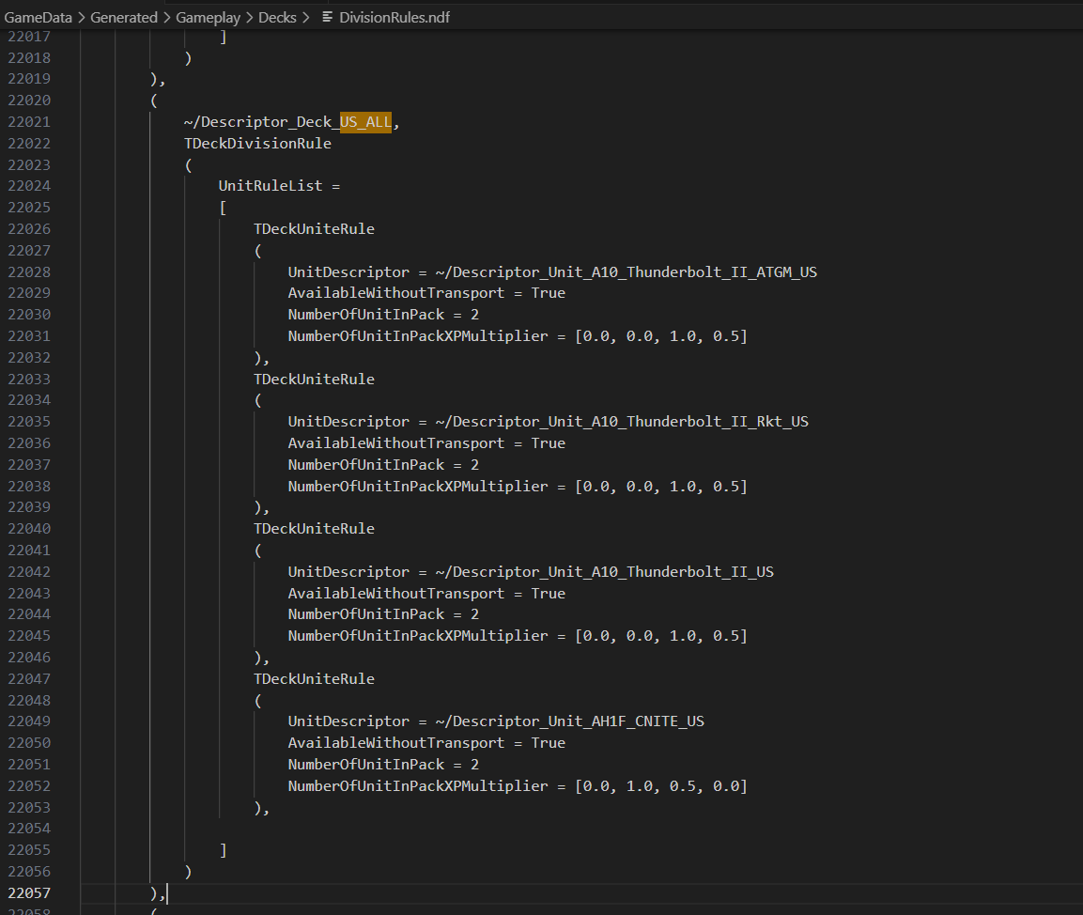

„~/Division Name“ same as in Division.ndf

TDeckUniteRule, copy them ofer for each Unit you have in the Division.ndf

Unit Name

[Green, Trained, Veteran, Elite]

1. GameData🡪Generated🡪Gameplay🡪Decks🡪DeckSerializer.ndf

Now that we have our Custom Division created, we need to Serialize the Deck. Each Unit and Each Deck in game have a Unique ID. This is what we do here. Just add a new Entry with the Division name and a Number, which is not used yet and add it to the DivisionIds map

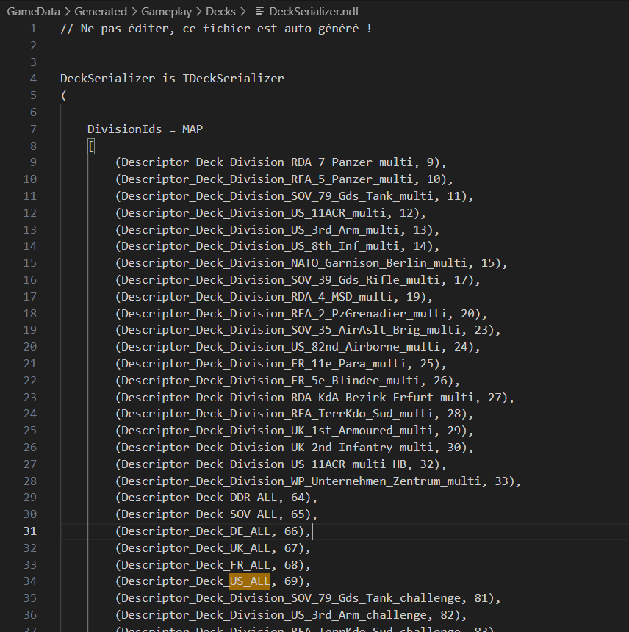

1. GameData🡪Generated🡪Gameplay🡪Decks🡪DivisionList.ndf

The last thing we need to do now is to add the Division to the DivisionList.ndf. All Decks need to be added here to be selectable in Game in the list. Just add into the List the ~/DeckName

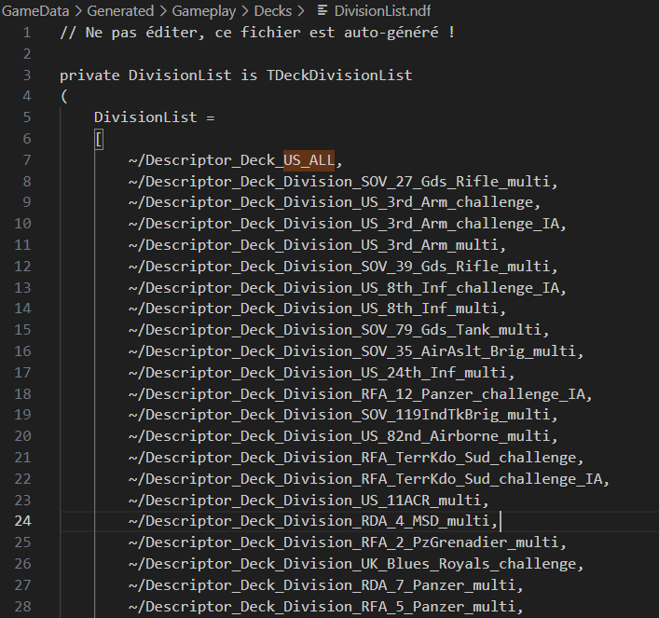

That is it. Do not forget to Save the changes, then generate, and upload the mod again.

Hope it helped,

BR,

18byte